1. Access the repo from this link:

<https://drive.google.com/open?id=1OdmgiZBYzYFQPRo6oMaOtKPQ0s31etJi>

1. Find list of projects:

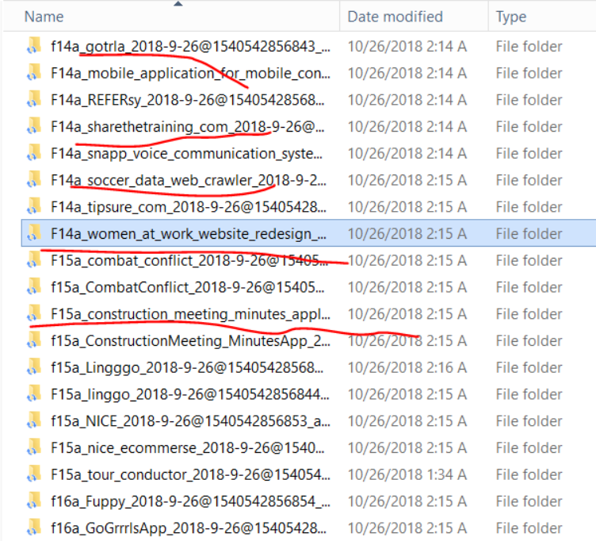

1. download the software from this link:

<https://sparxsystems.com/products/ea/trial/request.html>

1. create class diagrams:
2. find class_diagram.txt

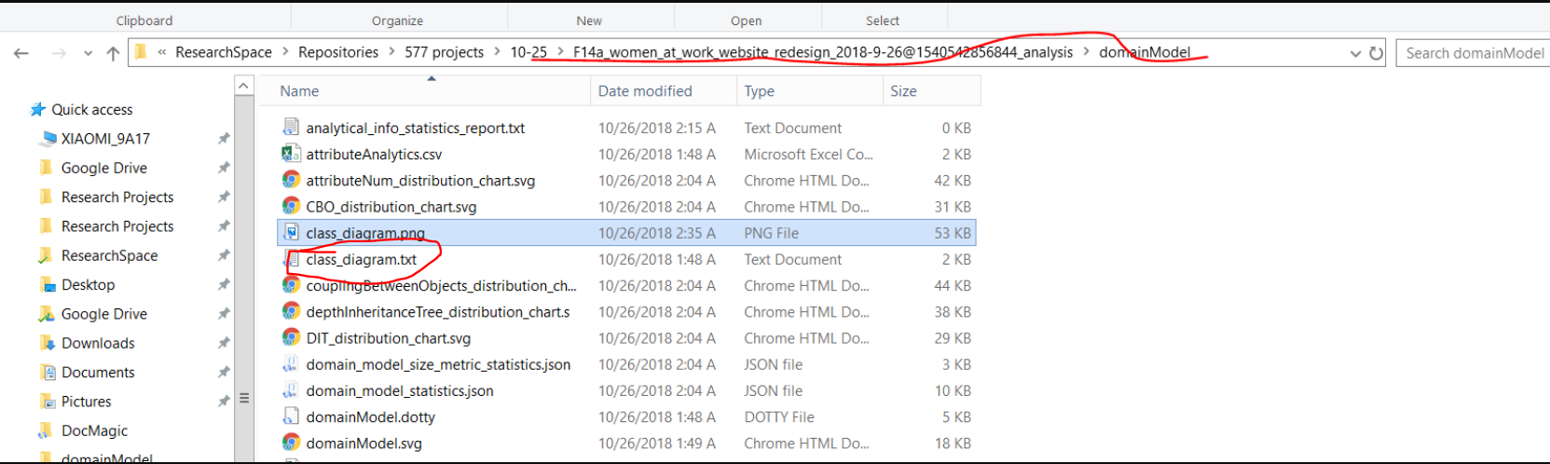

1. run command:

java -jar plantuml.jar class_diagram.txt -xmi

plantuml.jar is at the ./tools directory. This command will generate in the same folder class_diagram.xml

1. import class_diagram.xml into enterprise architect:

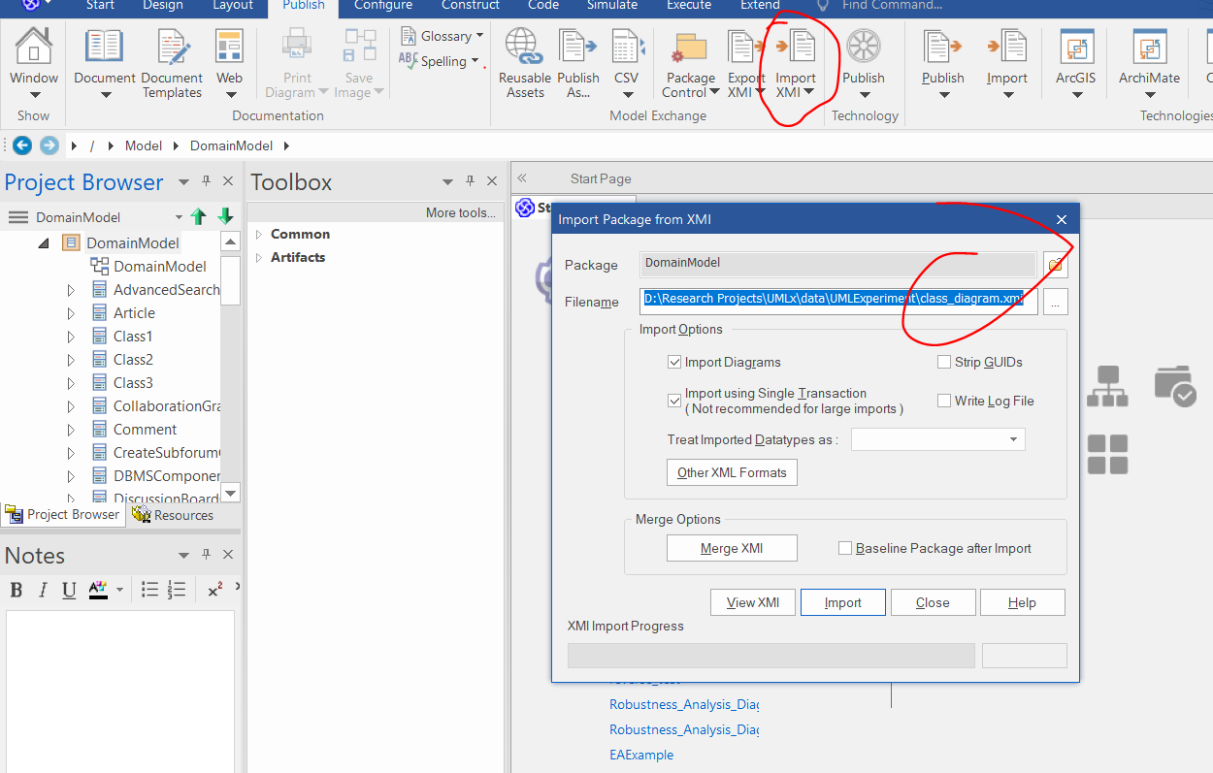

1. create a class diagram under the created package, and drag and drop the classes.

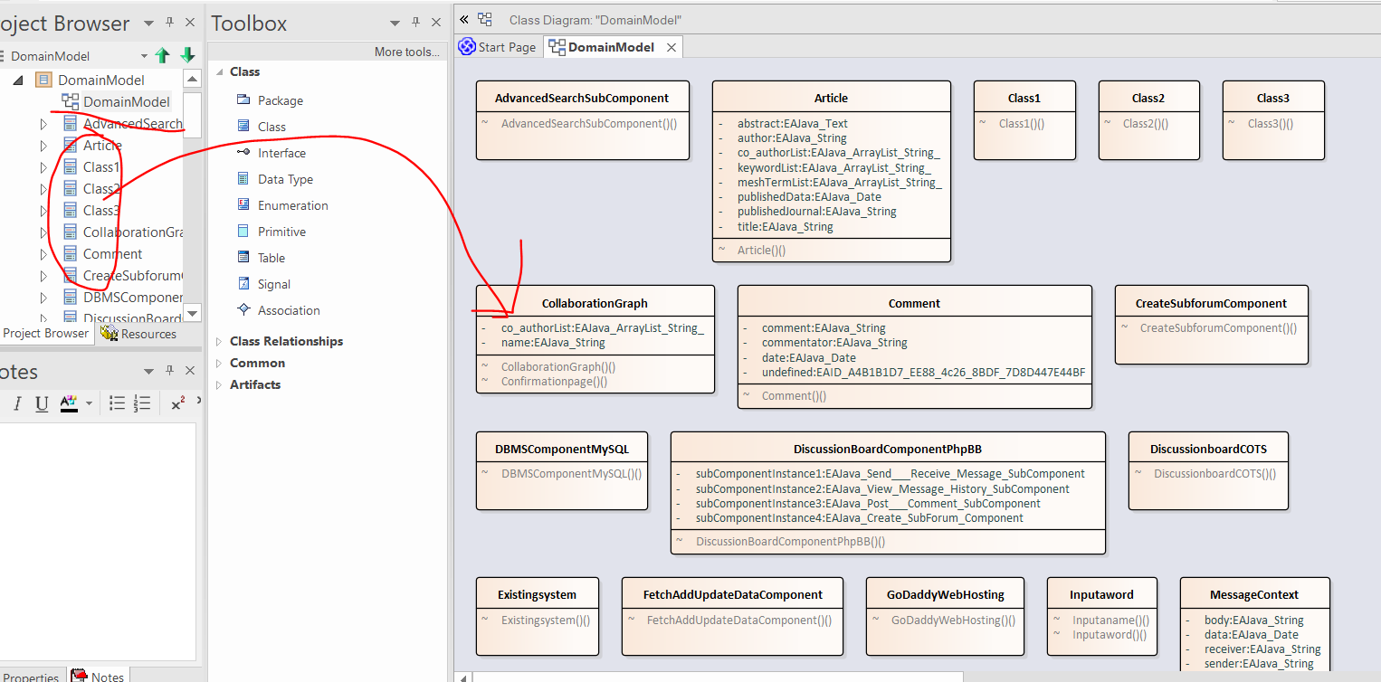

1. rename the package into “DomainModel” and the created class diagram as “DomainModel”
2. sort the classes

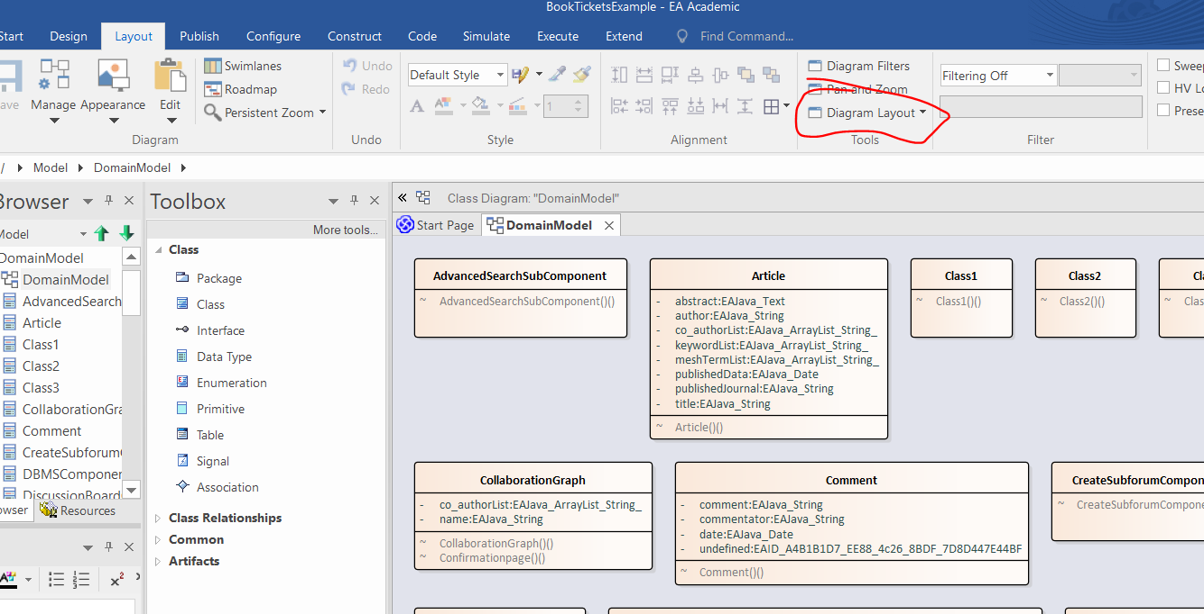

1. create sequence diagram

